# *OPERATING SYSTEM LAB ASSIGNMENT – V*

# 4ITRC2

Shreyansh Gupta

BE II Year

Information Technology ‘A’

Aim:

To create C programs for the different scheduling algorithms.

To perform:

Create and execute C programs for following CPU Scheduling Algorithms:

**1. First Come First Serve (FCFS) –**

PROGRAM –

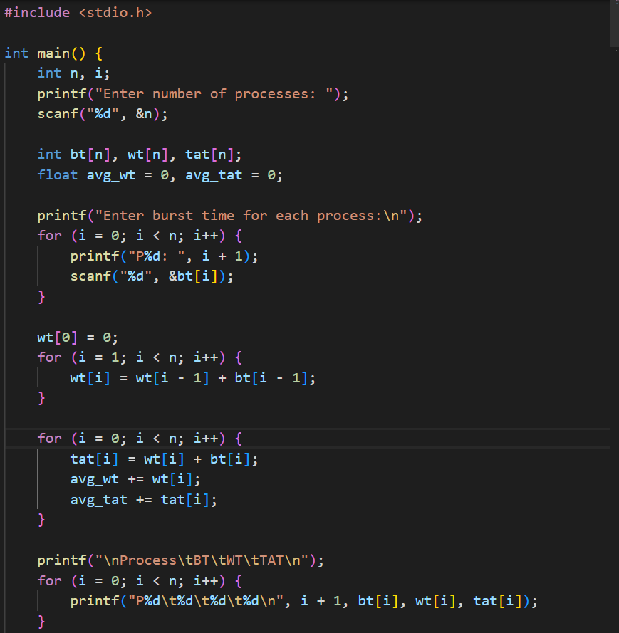

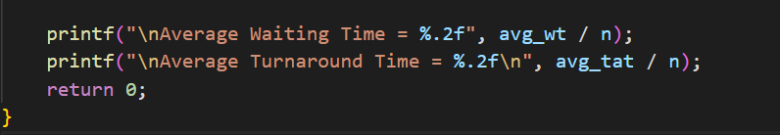

***Sample Output –***

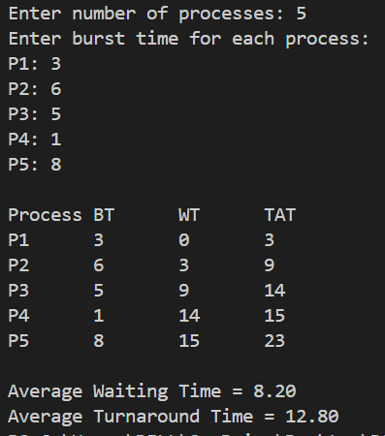

**2. Shortest Job First (SJF) –**

**Program –**

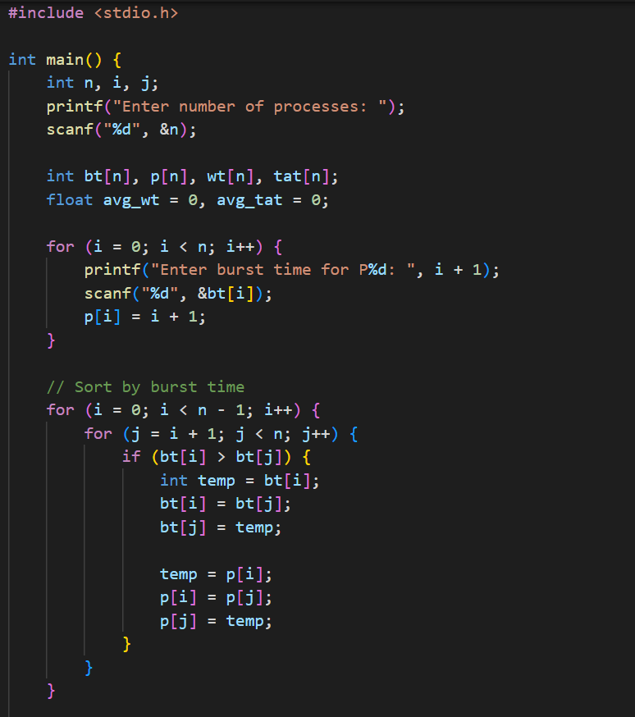

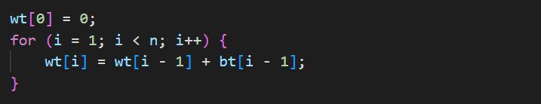

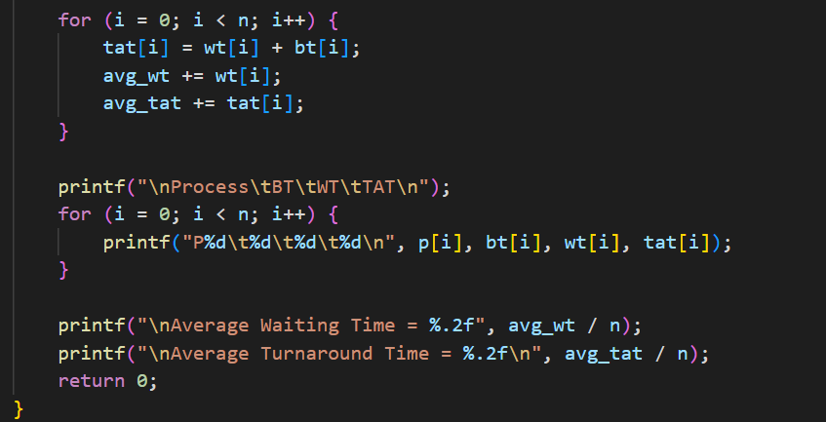

**Sample Output –**

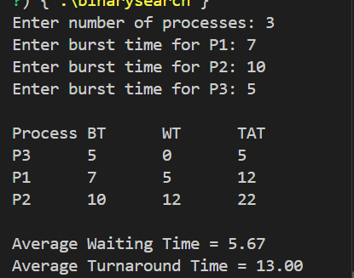

**3. Round Robin Scheduling –**

***Program –***

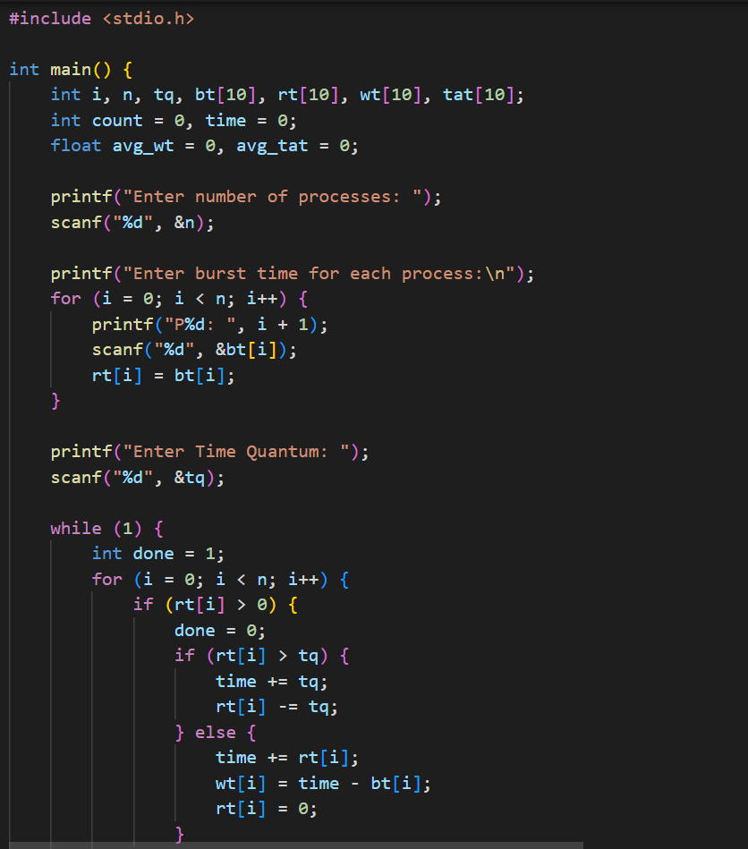

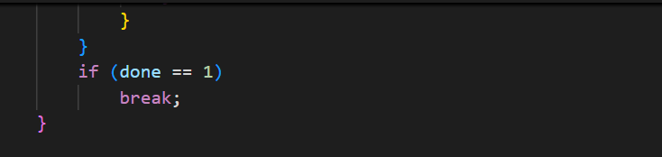

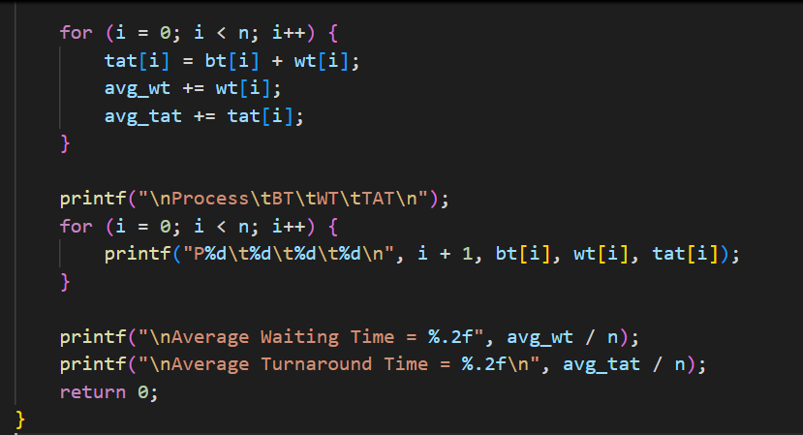

**Sample Output –**

